Computer Science I
2012-2013 Midterm Project
Reversi
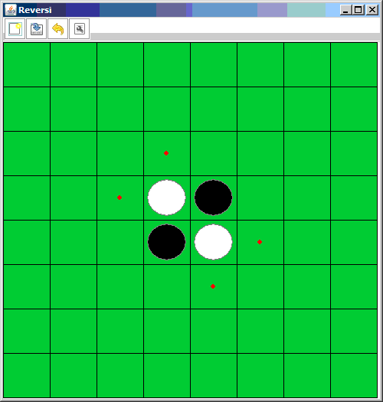

Instructions

The game starts on an 8 by 8 grid by placing 2 black/red and 2 blue/white disks in the center of the board. A coin toss determines which player goes first. On each turn,
 | place your piece on an empty square so that one  (or more) of the opponent's pieces are between  yours.  Here Red is about to capture a Blue piece ...
 | ... and Red is now captured.
You must capture ... they are the only valid moves. If you can't, then you lose a turn.
You win by having more of your pieces than the opponents at the end of the game.
Your program must keep track of the score and then determine when the game is over and who wins.
Your program should allow for a human vs human mode. However, to attain an A, you also need to allow for a human vs computer mode.

The grade breakdown is as follows (in addition to being able to fully articulate your program):

A program works as intended with minimal assistance and includes player vs computer mode.
A- program works as intended with minimal assistance and excludes player vs computer mode.
B(+) program works as intended but required assistance
C(+) program performs most, but not all of the required elements or is nearly but not complete
D program not complete, required significant assistance
F little or no effort given towards project

